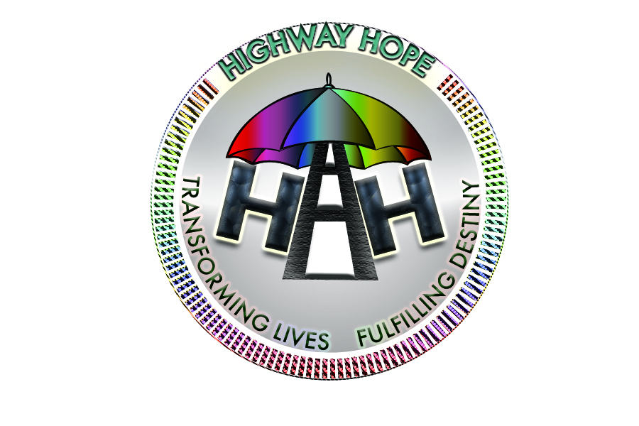
Highway Hope , 1 Matthews Lane, M12 4QW
Volunteer Information
Full Name |  | Title  (Mr, Mrs, Ms, Dr, Other) |  |  |  |  |  |  | Mobile No.
Address:
 |  |  |  |  | Postcode
Please circle your age | Under 18 |  | 18-25 | 25-40 |  | 41-59 | 60-75 |  |  | 76+
Please state your age if under 18 years:
Please complete this form and send it back as soon as possible, to allow us to arrange an interview.
Please indicate with a tick the type of voluntary work in which you are interested (Some areas are very popular - so it is best to tick a few options)
- Arts & Crafts |  | - Graphic designs
- Bead Making |  | - Health Education &Checks
- Book keeping |  | - Life Long Learning
- Cafe |  | - Man & Van Services
- Charity Shop |  | - Mental Health counseling & support
- Clerical |  | - Music School
- Community Events |  | - Online Marketing
- Community Reporting |  | - Reception
- Decorating/DIY |  | - Social Media – FB, Twitter, Instagram mgt
- Driving |  | - The CHIPS Night- A weekly Dinner Club, serving Healthy meals
- Fitness & Exercise |  | - Tuition Classes & Supplementary School
- Food Shop |  | - Website Management
- Fund raising
- Furniture Shop
- Gardening
Any further comments related to chosen areas to volunteer

Employment Status |  | Please state your working hours
If working please state your occupation

Experience: Please write below any voluntary work or relevant experience you may have.

Health: How would you describe your health?
Good |  | Fair |  | Poor
Please tell us about any disabilities which may affect your volunteer placement

Skills: Do you have any specialist skills, interesting hobbies which may be of use in Highway Hope.
e.g. Baking, Woodworking, Crafts, Playing the Piano, Singing, 1st Aid, Foreign Languages (non- English) spoken or written.

Why do you wish to volunteer at Highway Hope?
How did you hear about volunteering for us?

References
Please provide us with two referees who have known you for at least five years whom we may contact.
Note Referees should not be a family member, employees or volunteers currently working for Highway Hope
Title (Mrs, Mrs, Ms, Dr) |  | Full name
Relationship |  |  | Contact Number
Address
 |  |  |  |  |  | Postcode

Title (Mrs, Mrs, Ms, Dr) |  | Full name
Relationship |  |  | Contact Number
Address
 |  |  |  |  |  | Postcode

Please ensure you ask permission from these referees beforehand.

Criminal Convictions:
Owing to the vulnerability of some people using the centre , it is necessary for yu to disclose any criminal convictions.
Have you been convicted of any offence at any time?
If yes please give details

____________________________ _________________________ _______________
Name Signature Date

Equal Opportunities Form
We are very keen to draw on a genuine cross-section of the local community. Please complete the Equal Opportunities form, this allows Highway Hope to monitor this program.
Are you a British Citizen or an EU national? | Yes | No
If no: Do you have evidence of entitlement to enter and work in the UK | Yes | No

If no: what is our immigration status?

If no: How would you describe yourself? | Student | Visitor | Subject to Permit

Male |  | Female

Asian | Bangladeshi
Black (African) | Black (Caribbean)
Black (Other) | Chinese
Indian | Pakistani
White | Other

Official Notes

Date Received -
Documents Received -
Directorate-

